USER GUIDE

Manage Workers

September 2018

Version 1.02

Pharmacon ITC303/309 Group

Document Revisions

|  |  |  |
| --- | --- | --- |
| Date | Version Number | Document Changes |
| 1/09/2018 | 1.01 | Draft |
| 15/09/2018 | 1.02 | Initial |
|  |  |  |
|  |  |  |
|  |  |  |
|  |  |  |
|  |  |  |
|  |  |  |
|  |  |  |

Table of Contents

1 Introduction 4

1.1 Scope and Purpose 4

1.2 Process Overview 4

2 Manage Workers 5

2.1 Login – Administration User 5

2.1.1 To Log in to Pharmacy Error Tracker (PET) 5

2.2 Manage Workers 6

2.2.1 Navigate to Manage Workers 6

2.2.2 Create New Worker 8

# Introduction

## Scope and Purpose

The purpose of this user guide is to provide instructions on how to manage workers, i.e. add new workers.

No other features of the Pharmacy Error Tracker (PET) application will be discussed in this user guide.

* To be able to use PET, the user will need basic knowledge of logging into an online application and using a manage function to locate records.
* This feature is only available to a user with administrator rights.

## Process Overview

The administrator will need to log into PET using their valid username and password.

* The Welcome Page will be presented on successful login.
* The administrator will need to select Manage Workers via the menu bar or the button on the menu page.

# Manage Workers

To manage workers, the user will need to launch the application, login with a valid user name and password with administration rights. Using the Workers Details form, the user can add new workers.

## Login – Administration User

User must have access to the application.

User must have a valid username and password with administration rights.

### To Log in to Pharmacy Error Tracker (PET)

1. Launch the application.
2. Click in the Username field.
3. Enter username.
4. Tab or click in Password field.
5. Enter password.

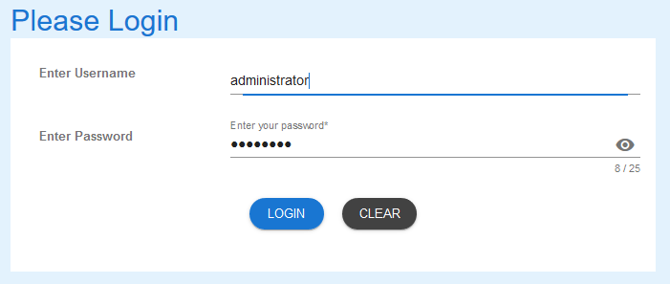

1. Select LOGIN to access PET.

NOTE:

Users entering an invalid username and/or password will not beable to access PET.

## Manage Workers

### Navigate to Manage Workers

1. From the Welcome Page, there are two ways to navigate to “Manage Workers”:
   1. Select the “Manage Workers” from the list



* 1. From the Menu Bar, hover your mouse over “Manage…” and select “Manage Workers”

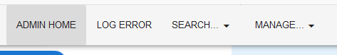

1. The Workers Details form will appear.

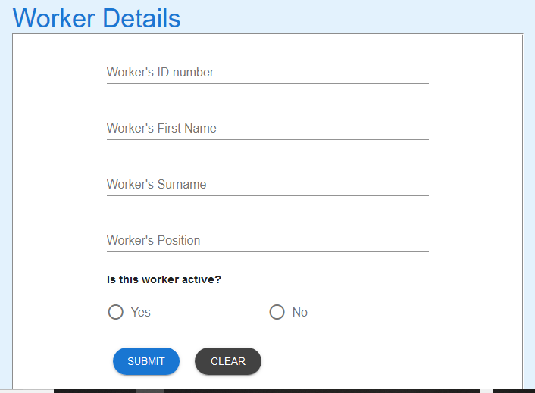

### Create New Worker

1. Enter the details of the new Worker. The worker id must **not** have been used before.

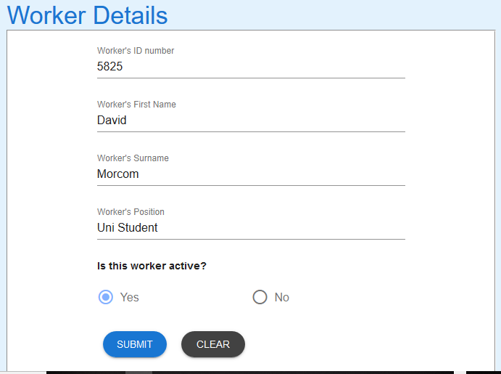

1. Select the SUBMIT button and success message appears.

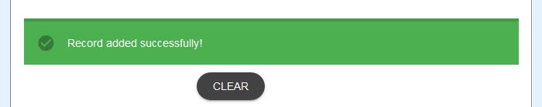

1. Use the Search Workers User Guide for details to search the database to see record just created.

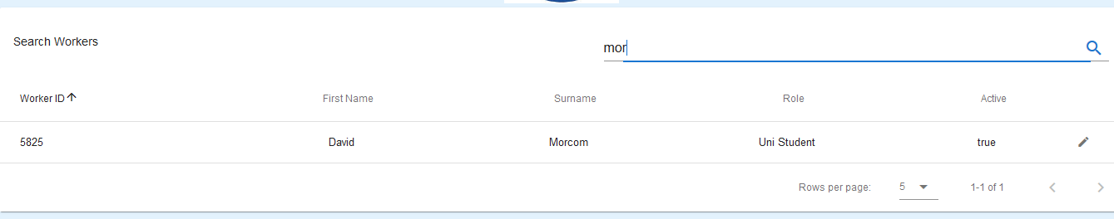

If you encounter issues not addressed by this user guide, please contact your account manager for additional support.